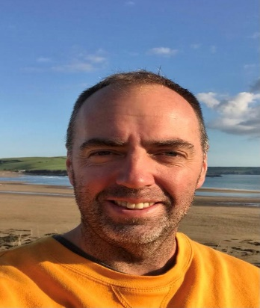
Colin Cocking
Huxley Lodge
Elliotts Hill
Brixton
PL8 2AG

07738 261012
colin.cocking@brixtonparishcouncil.org.uk

I was born and raised in the small fishing town of St Ives, Cornwall which taught me a lot about community spirit.
I have lived in Brixton for over 11 years, with my partner’s family having ties to the village for 50 years or more. I have three children all who have attended Brixton St Marys School. Much of my free time is spent in and around the water and I am a very keen and active environmentalist.
Working in and around the village I have a daily connection with the parishioners and can see and hear about their issues and concerns. I want to give back to the community where I live and work. Having a young family, I am looking to be the voice for my children and the rest of the youth population in the village. I am looking to champion community led events with the aim to bring the village together, these are important to create a sense of community and pride in our village.
I feel the council benefits from strong leadership and has a great mix of experience and young blood to best serve the community of Brixton and I look forward to playing my part on the council.”

