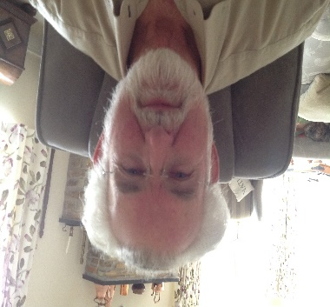
Richard Du Pont
Mapletree
1 Chittleburn Close
Brixton
Plymouth
PL8 2FL
01752 880122
richarddupont@btinternet.com

Although only recently moved to Brixton, I have lived in two villages, one in Surrey where I was a Parish Councillor for 5 years and another in Worcestershire where I was a Parish Councillor for 12 years and a District Councillor for 9 years. So I have a lot of experience dealing with people and their problems.
I also have been self-employed for 18 years and with my own business for 20 years.
I have always felt one should contribute to the community one lives in, and this is my way of doing it. I hope my experience in local government and business will be of use to the people of Brixton.

