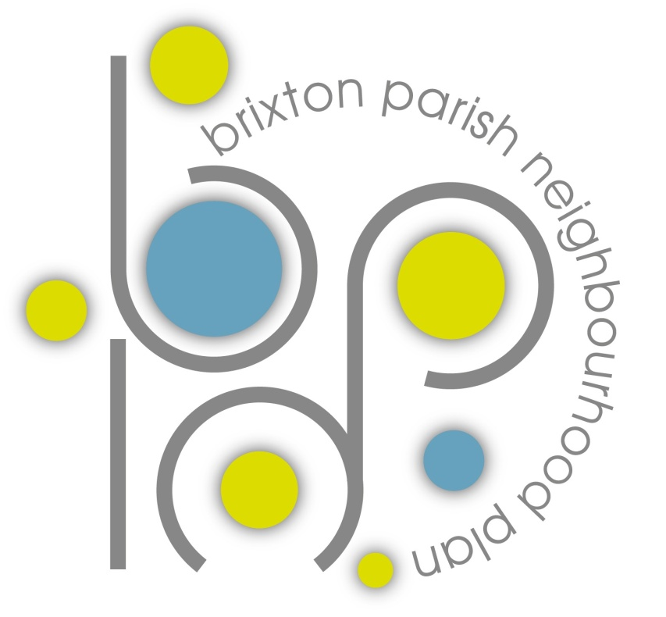
Brixton Parish Council Neighbourhood Plan

Vision and Objectives

A lot of work has been done throughout the year in seeking your views on the future of Brixton parish for the next 15 years through the Neighbourhood Plan process. The Neighbourhood Plan Group would like to thank everyone who completed the questionnaires and attended the consultation event in July 2016. As a result the Group has a considerable amount of information about the wishes and thoughts for the future from the whole community; and has started the first draft of a vision statement and objectives which form the basis of the plan. Once these have been agreed then the Group can start writing polices which will affect planning for the parish from 2016 – 2030. There is a requirement for further consultation on the vision and objectives and we are doing this in a variety of ways including through the Brixton Magazine. Please consider the vision and objectives below. These are based on the themes in the community questionnaire and let us know your views by emailing brixtonplan@gmail.com or writing your comments and leaving them in boxes placed in the Shop in Brixton, Serpells at Blackpool Farm, Rogers Garage, St. Marys School and Albion Oaks Rugby Club by the 10th December 2016.

Vision statement

Introduction
Brixton parish offers the opportunity to embrace village and rural life:-a sense of community, tranquility, a safe, environment with public green spaces and beautiful landscapes. Our community benefits from both the South Devon Area of Outstanding Natural Beauty and the close proximity to the historic port city of Plymouth, with all the advantages of connectivity, culture, educational facilities, heritage, employment, sport and commerce.

Vision
Our vision is to conserve and enhance the rural and historic environment of Brixton Parish, with its beautiful landscape of woods, farmland and estuary; to retain the identity and independent character of Brixton village and its surrounding hamlets; to nurture thriving communities across the parish by providing improved facilities and opportunities to meet the needs and wishes of the community.

Objectives

Environment
- To proactively conserve, protect and enhance landscape features of local significance including but not limited to, the South Devon AONB, agricultural land, the Yealm estuary and green corridors between neighbouring urban centres.
- To protect and encourage biodiversity within the parish.
- To promote new local green spaces and to enhance the existing provision.
- To identify opportunities for renewable energy generation with low visual impact upon the landscape.
- To conserve and maintain historical features such as Estate walling, parkland and woodland, bridges, tracks and hedgerows.

Transport
- To improve and increase the quality and quantity of safe, sustainable transport links, including bus, cycle and footpath routes.

Community Facilities
- To support existing and encourage new facilities within the parish and to promote sharing and collaboration with neighbouring communities.
- To improve parking provision across the parish.

Employment
- To encourage employment growth in sustainable locations.

Sport and Recreation
- To encourage opportunities for improved outdoor sports and recreation facilities.
- To increase the recreational footpath and cycle network.
- To look for opportunities to provide bridleways.
- To encourage initiatives that will improve the health and wellbeing of parishioners.

Development
- Development should reflect the rural character of Brixton parish; be appropriate to the setting and be limited to conserve the independent identity of Brixton village.
- Development that utilises pre-developed (brown field) sites should be given priority over agricultural land. Development proposed within the AONB will not normally be acceptable.

Reports from the consultations as well as the draft vision and objectives can be found on the Brixton Parish Council website www.brixtonparishcouncil.org.uk

